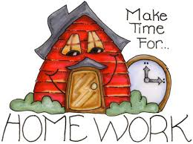

**HOLIDAY HOMEWORK**

**SESSION: 2019-2020**

**CLASS-NURSERY**

*Dear Students,*

*This summer vacations do not just sit idle and watch television. Let’s your creativity flourish by indulging in some simple and fun filling activities.*

*Parents are advised to guide, motivate and facilitate their wards to complete their holiday’s homework. Children are instructed to do their homework themselves their own handwriting. In addition to activity, project, written and learning work. We are planning to transform you into a versatile personality.*

**1. Walk Together:** Go for walks with the family. You will realize you have God’s greatest gift….Nature and your Family.

**2. Cultivate Manners:** Remember the 4 magic words PLEASE, THANK YOU, SORRY and EXCUSE ME. Make these a part of your personality.

**3. Play Outdoor Games:** Computer games are good and they sharpen your intellect, but you need some exercise too for rest your body. Go for cycling, play badminton, cricket, kho- kho, catch, hide and seek anything that will make you run.

**4. Care and Concern**: This is your chance to look after your parents, grandparents, elders and even your younger brothers and sisters. You can surely be of some help around the house.

**5. Conversation: GOOD MORNING, GOOD AFTERNOON, GOOD EVENING, GOOD NIGHT**

**-**May I go to washroom?

**-**May I drink water?

**-**May I come in?

-How are you?

-What is your name?

-I am hungry.

-I am very thirsty.

**-USE WORDS LIKE GIVE,TAKE MORE,WANT,NEED,LESS.**

* Nature has provided us with wonderful and vibrant colors. They spread happiness and cheer. Collect things from garden and paste them on A4 size colored sheet.
* Make a colorful collage on A-4 sheets of your favorite things some are given below for example:-

Favorite

* Food
* Sport
* Color
* Toy
* Drink
* Movie Actor/Actress
* Car
* Movie
* Cartoon Character
* Flower
* Fruit
* Gift
* T.V Channel
* Vegetable

You are free to add more.

**Make one scrapbook of alphabets A to Z with pictures of 4 new things like**

**A for alligator , arrow, ant , axe.**

** **

 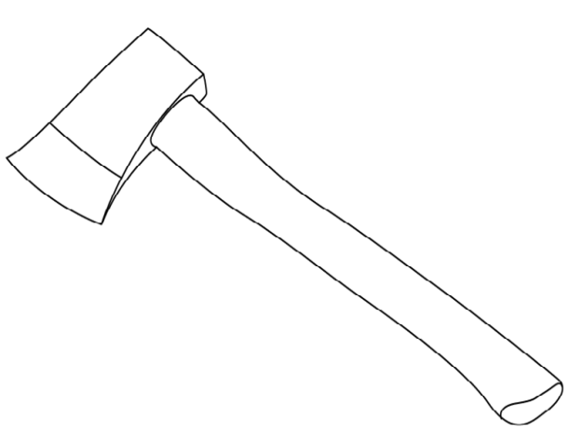

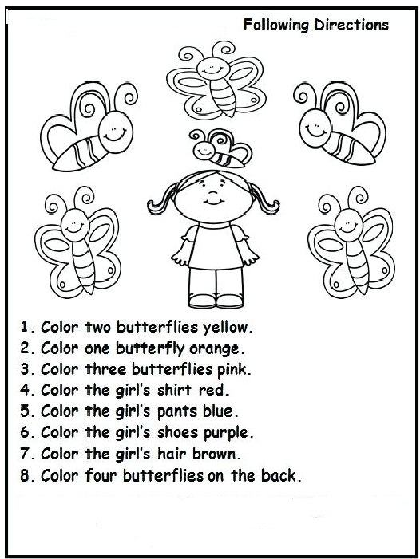

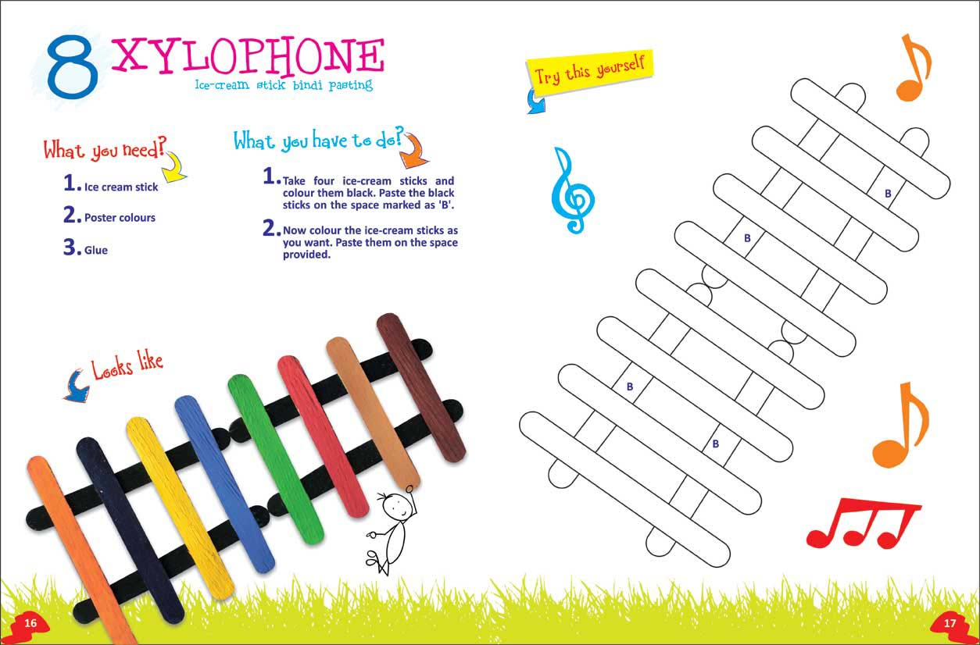

**Decorate the fish with your Thumb Impression**

