HOLIDAY HOMEWORK OF PRE-NURSERY

*Dear Students,*

*This summer vacations do not just sit idle and watch television. Let’s your creativity flourish by indulging in some simple and fun filling activities.*

* DAILY PRACTICE SLEEPING LINE, SLANTING LINE, STANDING LINE. (TOTAL 5 PAGES OF EACH).
* DAILY REVISE A TO H ALPHABETS ORALLY.
* COMPLETE THE GIVEN COLOURING SHEETS.
* DAILY REVISE 1 TO 10 COUNTING ORALLY.
* MAKE ONE FAMILY TREE WITH THE HELP OF PARENTS.SHOW THREE GENERATIONS (GRANDPARENTS, PARENTS, CHILDREN).PASTE PICTURES OF THE SAME .USE COTTON TAPPING IN COLOURING TREE.
* LEARN AND PREPARE PICTURE DICTIONARY OF BOTH ENGLISH ALPHABETS A TO Z AND HINDI VOWELS WITH PICTURES WITH THE HELP OF PARENTS.
* DRAW OUTLINE OF ANY FIVE SHAPES AND FILL THEM USING PAPER-TEARING TECHNIQUE.

COLOUR THE FRUITS

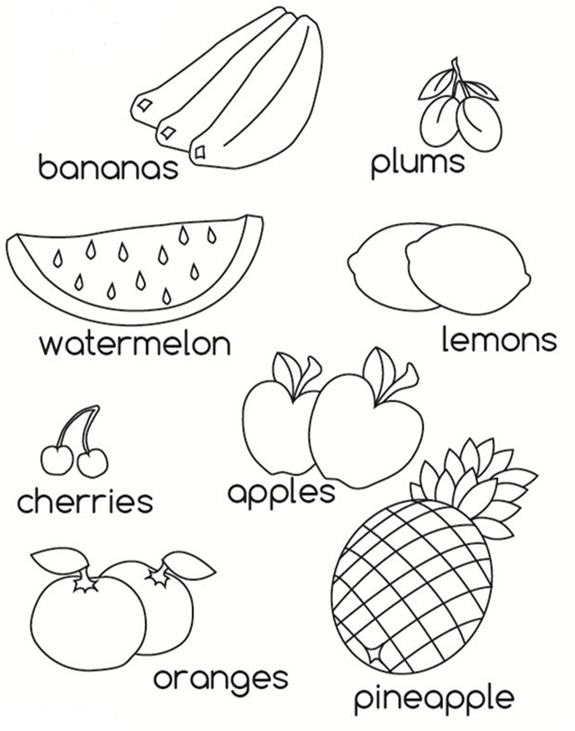

Recognition of colors

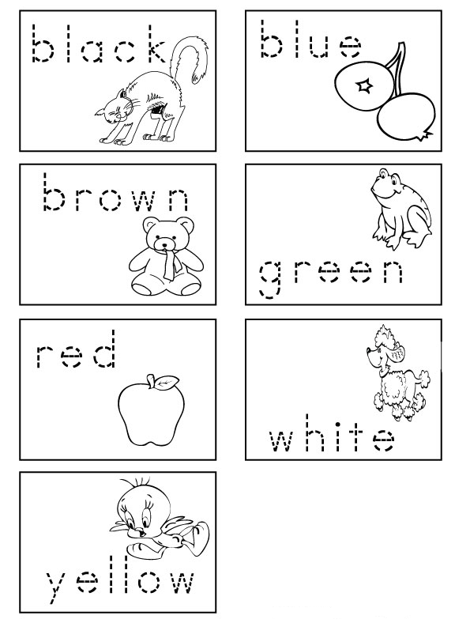

Color the water animal

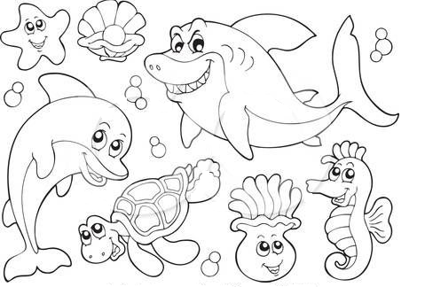

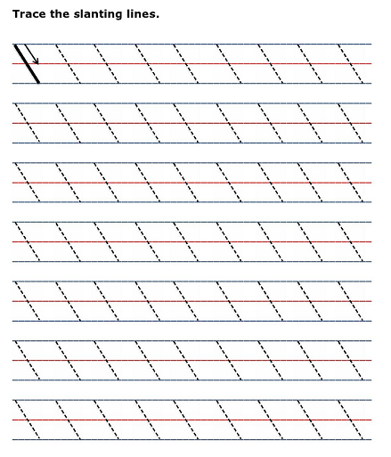

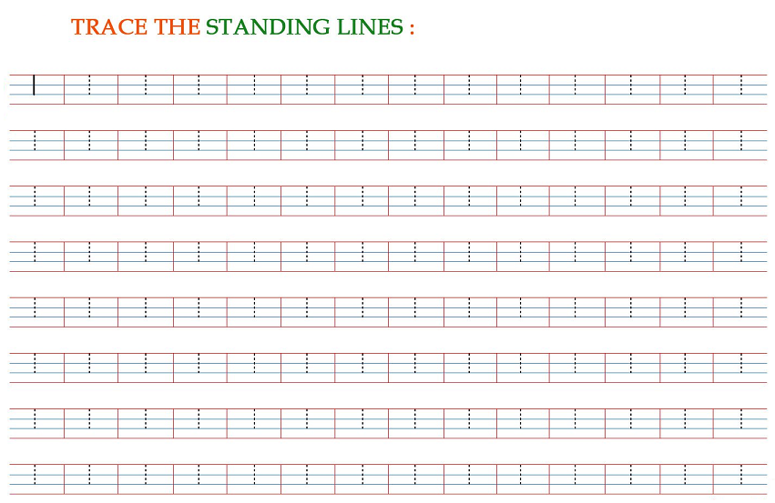

**Trace the Sleeping Lines:-**

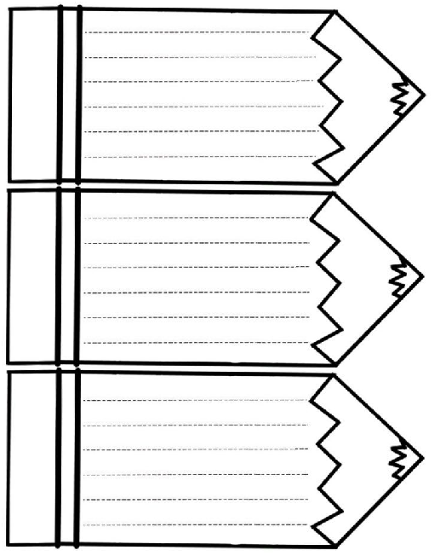

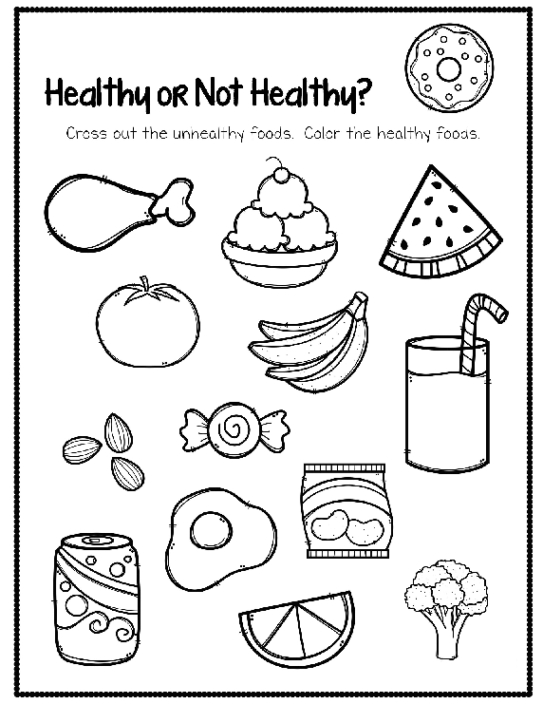

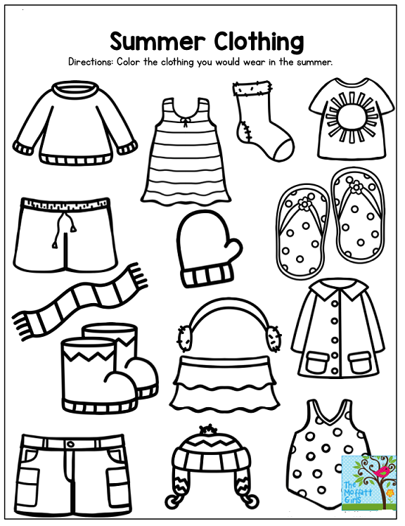

**Do thumb painting in circles and rest color :-**

